MGMS – Institution

Functional Specification Document

Ver. 1.4

Version History
Date | Description

Table of Contents

Version History 2
1 Introduction 4
1.1 Purpose 4
1.2 Scope 4
1.3 Assumptions 4
1.4 Constraints 4
2 Main Menu – Institution 4
2.1 Sub menu – Add Department 4
2.2 Sub menu – Institutions List 6
3 Business Rules 7
4 Status Messages 7

Introduction

Purpose

This document provides the requirements and functional specifications for the Institution menu in the Multisite Grant Management System project.
This is not a project plan or a design document. It is a guide for system architecture and development, not for phasing, timelines or deliverables.
Finally, this is a ‘living document’ and the specification will change, continuously, as the project proceeds. More details will be added and the existing information edited as the requirements, scenarios and use cases evolve in the course of the project.

Scope

While creating Site Administrator profile, the Institution details are captured for the first time. Any subsequent additions and modifications to those details are completed through the sections below. Details captured include address, contact no:, email ID, and associated departments.

Assumptions

Constraints

Main Menu – Institution

Institution is the organization which undertakes own projects on self funding, assigns projects to other similar institutions along with grants, and also takes up projects from other organizations, receiving grant allocation from them.
An institution will have several departments in it involved in different functions.
Provision is made for updating institution and department details.

Sub menu – Add Department

Figure 1: Create Department
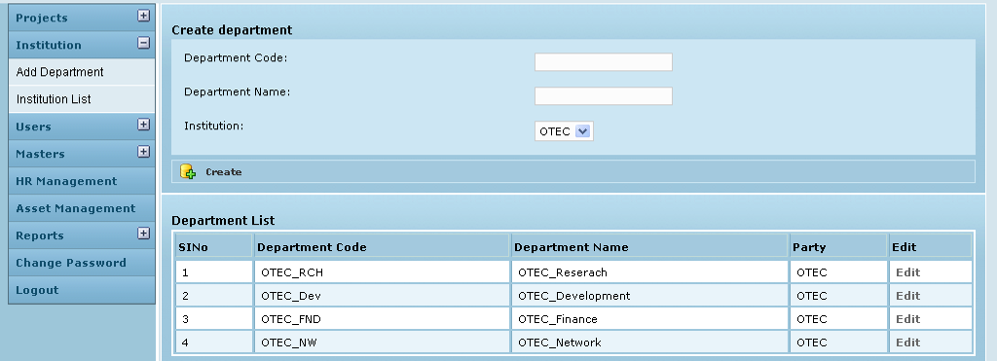

Field /Label | Input-Control | Data Type | Remarks /Edit Check
Create Department
Department Code: | Textbox | String
Department Name: | Textbox | String
Institution: | Listbox | String
Active: | Listbox | char(1)
Create | Button |  | The details are saved and added as a new row to the table below
Department List
(Table fields)
SlNo | Auto populated
Department Code | Auto populated | String
Name | Auto populated | String
Party | Auto populated | String
Active | Auto populated | char(1)
Edit | “Edit” - link

Edit Department

Figure 2: Edit Department
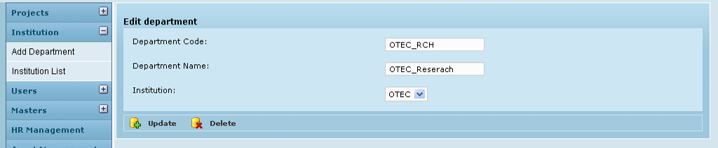

Field /Label | Input-Control | Data Type | Remarks /Edit Check
Edit Department
Department Code: | Auto populated & editable Textbox | String
Department Name: | Auto populated & editable Textbox | String
Institution: | Listbox; Auto populated & editable | String
Active: | Listbox; Auto populated & editable | char(1)
Update | Button |  | Message: “Department details updated successfully”

Sub menu – Institutions List

Figure 3: Institution List
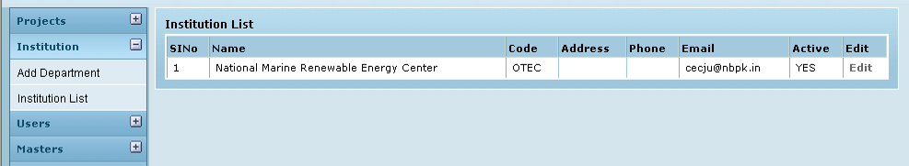

Field /Label | Input-Control | Data Type | Remarks / Edit Check
Institution List
(table fields)
SlNo | Auto increment populated
Name | Auto populated
Code | Auto populated
Address | Auto populated
Phone | Auto populated
Email | Auto populated
Active | Auto populated
Edit | “Edit” button

Edit Institution

Figure 4: Edit Institution
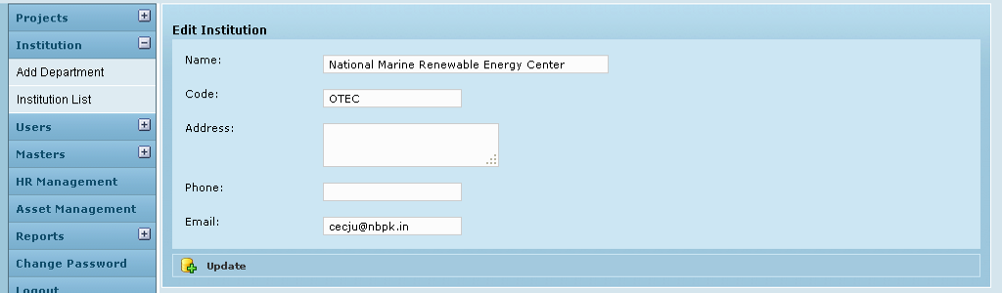

Field /Label | Input-Control | Data Type | Remarks/Edit Check
Edit Institution
Name | Textbox | String
Code | Textbox | String
Address | Textarea | String
Phone | Textbox | String
Email | Textbox | String
Active | Listbox | char(1)
Update | Button |  | Message: “Institution details updated successfully”

Business Rules

Status Messages

Sl No | Status Message
1 | Created Successfully
2 | Updated Successfully
3 | Deleted Successfully
4 | The Requested Record Not Found
5 | The Record can't be deleted, Already in use
6 | The Record Already Exists
7 | Please Enter a valid email address
8 | You can not delete yourself, please login as another admin and try again
9 | The Institution involved in grant Allocation, so could not delete
10 | Grant Allocation done by the Grant Agency, so could not delete

